Maximum Mass Limit of Stars on the Main Sequence
By
Christopher Oakley
ASTR8100
March 16, 2008
When discussing the processes of star creation and propagation, one of the main concerns is the maximum mass limit of a star. Obviously, this is a concern with a complex answer. The maximum mass of a star is dependent on many factors including, stellar winds, metallicity, and the cloud from which it is formed. Another concern is the existence of a maximum mass cut-off. Theorists have proposed such a limit for over 50 years, and the values are dependent on the conditions of the stars creation. Aside from these interests, the study of massive starts offers a wealth of information about our universe. Massive stellar formation can give insight into the evolution of the early universe with understanding of Population III stars. The effects of these stars are also of significant interest to those studying star and planet formation, as well as the composition of the ISM.
Currently a mechanism is understood for the creation of massive stars. Gravitational collapse creates optically thick regions of the cloud that can eventually form protostars. It’s important to note that according to Zinnaker and Yorke, this is a nonhomolgous collapse, meaning that the distribution of material changes, as opposed to a homologous self-similar collapse [8]. Material accretes on to the protostellar object, and for lower mass stars, this accretion ends before hydrogen fusion begins. For objects destined to be high mass stars, accretion continues into the hydrogen fusion stage, and radiation driven winds are developed. The winds, outflows, and radiation produced by these objects have a strong influence on their surrounding medium, and will go supernova after ~3 Myr [9] [5].
The first step towards the formation of a high-mass star is a core or a clump of molecular gas in a giant molecular cloud. Cold dense filaments can be created by turbulent gas in giant molecular clouds. Turbulent and pressurized clouds may allow sufficient material to be available for this type of formation. An alternate idea suggests that this scenario is more transient due to the random motion within the cloud. Simulations of smoothed particle hydrodynamics have shown this collapse and fragmentation that marks the birth of these high-mass objects. Between the two approaches the only difference is whether or not the protostellar object has to compete for materials or not.
The final key element that drives the collapse is the magnetic fields that affect the molecular cloud. Magnetohydrodynamic simulations indicate that without magnetic fields the required cores are not likely to develop. These simulations assume driven turbulence as opposed to decaying turbulence. The outflows of these massive protostars keep the object close to virial equilibrium as opposed to the turbulence. The implications of this work are far reaching in the fact that the IMF may be influenced by the outflows of these objects. Essentially, there are no conclusive observations that indicate whether a slow or a fast method applies to this type of stellar formation.
Regardless of the approach, some of the gas in these filaments can become gravitationally bound and begin the collapse necessary to begin the star formation process. This gravitation must overcome magnetic forces, any rotation, and other form s of pressure to continue stellar formation. The densest portions of the star collapse fastest, while the less dense layers have a greater paucity of matter. This implies that the Jeans mass decreases during the collapse. When the densest parts become optically thick, the gas can heat up and increase the pressure significantly.
Rotational forces often increase during the gravitational collapse due to conservation of angular momentum, which creates accretion disks. This phenomenon is not unique to high mass stars, but implies there are significant changes in mass of the object from both influxes and outflows of material.
Eventually the temperature reaches critical point where the hydrogen in the cloud fragment dissociates and a second core of material falls on the previous core. The core grows in mass towards hydrogen burning densities and temperatures. The evolution of the star occurs in four components that are effectively ignorant of each other; the central core, accretion of matter onto the disk, material movement inward within the disk, the transportation zone between the disk and the core. Fundamentally the formation process is similar for both high and low mass stellar creation, excluding the assumption that each of the above components is not affecting each other. Due to complex geometry, the exact method for accretion of matter onto the disk is an active theoretical topic.
One crucial element in high mass stellar accretion is referred to by Zinnecker as dust destruction, where at a certain temperature dust dissociates and opacity of the material is reduced. Hydrostatic simulations that assume spherically symmetric accretion could create stars of 150M_{solar} [9]. A reduction in effective opacity can also occur by radiation escape through gap areas that have lower density between shocks that are driven by radiation flux of the object.
Several prospective methods exist describing the creation of massive stars. Obviously, these methods are dependent on different initial conditions of the molecular cloud and propertied of the ISM. The most prominent are the methods of monolithic collapse, competitive accretion and runaway, and stellar collisions or mergers. Zinnecker notes that the work of Yorke and Sonnhalter has considered the collapse of rotating nonmagnetic massive molecular cores up to 120 M_{solar} using frequency dependent radiation hydrodynamics simulation code. There is an appreciable effect of frequency on opacity and the flux within the disk which lends substance to this approach. Even though this does not represent an upper limit for star mass, scenarios could arise where a denser flow within a filament or fragment could create stars of even greater masses.
Speculations have been made in reference to the effect that outflows have on accretion in this method of formation. Magnetized disks are being studied with the intention to understand the flow of vertical radiation within the disk. This can explain super-Eddington accretion in many luminous systems including very massive stars. Efficient angular momentum transfer can also result from weak magnetic fields in the disk, turbulence that comes from gravitational instabilities in both magnetized and nonmagnetized disks. Ultimately, whether a cloud is magnetically sub/supercritical may help determine if massive stars are created in isolated environments or in clusters. Tidal effects of nearby stars can also cause these gravitational instabilities. Having gravitational bodies near by may lead to increased accretion that can aid in massive star formation.
Fig. 1 – An example of a close binary pair and the associated inner accretion disk. An azimuthal cavity is evacuated by both radiation and stellar wind. In this image the disk is shielded by ionized Hydrogen fronts. Size is not to scale.[9].

Competitive accretion is also a viable method for creation of massive stars. Bonnell presents 3D simulations of stellar mass growth by competitive accretion in small young clusters. In this method, growth is promoted by the size and composition of the stars accretion domain. As mass increases, the gravitational reach increases as well. This implies that stars that are born in the center of a cluster have a greater opportunity to reach higher masses. This is partially due to the fact that gas will settle into the more central parts of the potential in the cloud. Protostars that are off-center are limited by the mass in that specific location in the cloud, where the same object in the center of the cloud can draw on the entire cloud as its supply of accretion material.
Competitive accretion comes to the conclusion that eventually these accretion domains will eventually overlap. This eventually means that stars in clouds or in local clumps in clouds will compete for the same material, and the largest stars will be formed in the most ideal conditions and occur very rarely. The lynchpin of this method is the fact simulations were run for strongly gravitationally bound clouds where turbulence was negligible. Arguments have been made by Krumholtz, McKee, and Klein that protostellar masses cannot grow in this type of medium [9]. More recent simulations have corrected and increased the turbulence, and small turbulent velocities were found between protostars and the neighboring medium. The problem suspected above is not as serious as first implied, because protostars are moving with neighboring gas in a similar global motion until they meet with an uncorrelated gas.
Omukai and Palla have worked with the mass accretion rate which is a possible catalyst for massive star creation. Their results indicate that the earliest stages are independent of accretion rate [7]. Later in the stars evolution there is a critical mass accretion rate that brings the luminosity to the Eddington Limit before nuclear burning has begun. The M_{crit} is a value near 4x10⁻³ M_{solar} yr ⁻¹. This phase is followed by rapid radius expansion, which can possibly lead to reversal of the accretion flow. For time dependent accretion rates, fluctuations in accretion rate can have dramatic effects on the mass of the resulting star. This work uses very small values for Z, and in the Z =0 case, reduced gas temperatures lead to smaller changes in accretion rate. Other critical metallicities exist including Z~0.01 Z_{solar}. This significantly limits the amount of material that can be accreted. Palla and Omukai also note that strong stellar winds have a strong effect, which is blowing off envelope material. Obviously with less stellar material the star can quickly move to the mains sequence as a lower mass star.
The notion of a stellar merger is plagued by the concern that massive stars would me packed too tightly into dense clusters, and that there was not a sufficiently large reservoir of gas for a monolithic collapse. This concern is assuaged by the fact that massive stars occur in OB associations that are not a densely populated cluster. Stellar mergers are rare objects and only relevant in the richest youngest clusters.
One of the goals of theoretical Astrophysics is to understand the parameters that govern star formation. One of the key elements in star formation is an understanding of the initial mass function (IMF). Since its introduction by Salpeter in 1955, the IMF has been slightly refined by observational studies [1]. Recent modeling has shown that the Salpeter value of -1.35 is an adequate average value for the expression for the IMF [2].
Figure 2 shows that the expectation value of m_{max} has the potential to be greater than generally accepted maximum of 100-120 M_{solar}. It is to be noted that this analysis by Oey et al. is highly dependent on the value used for the Salpeter slope. For the accepted average value of the Salpeter slope, there should be a cutoff at 120-200 M_{solar}.

Fig. 2 – Graph of the expectation value of m_{max} vs. upper limit mass m_{up} for N = 100, 250, and 1000 stars. The Graph assumes a Salpeter IMF and a minimum mass limit of 10M_{solar} [1].

Work done by Elmegreen includes an exponential decrease to the IMF with the intention of simulating the competition for materials in denser turbulent clouds. There should be a turn down for stars of mass greater than 100M_{solar} for several reasons. The main argument for this limit is the apparent structure of the universe on kilo parsec scales. Without this limitation, one could assume that the cloud is only a small part of a larger gas structure that can be used for stellar formation. This observation by Elmegreen suggests that the power-law IMF drops more rapidly than the Salpeter slope at masses near several hundred solar masses [2].
Figure 4 shows a high mass turn-down that would account for the lack of super massive stars under normal star-formation conditions. This data also agrees with the observation of the Salpeter slope to out to a value of approximately 100-130 solar masses in work by Massey et al. [5][2]. Still, concerns are that it is possible to get 130 M_{solar} stars in dense clusters, yet not having any stars of 300 M_{solar} in the entire galaxy.

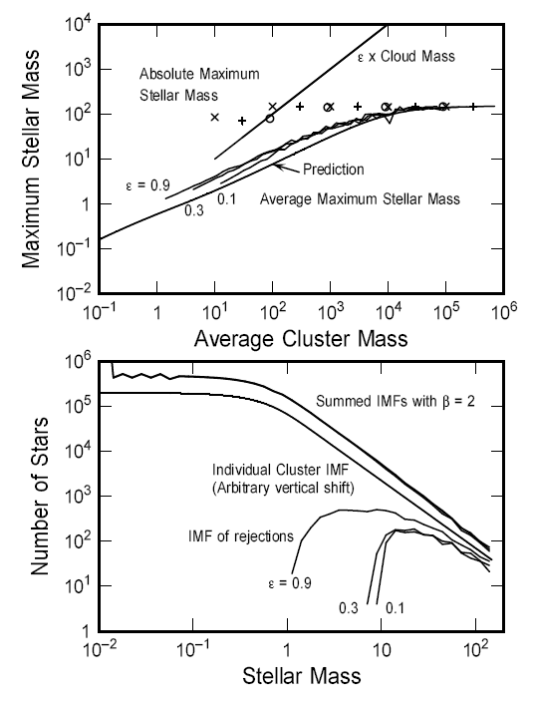
Fig 3 – Data from a Monte Carlo IMF model. The bottom panel shows different star-formation efficiencies, ε, as well as the cluster IMF. The top panel shows average maximum stellar mass in a cluster and the cluster mass. The “x”, “+”, “o” represent the cases ε = 0.1, 0.3, and 0.9 respectively with the theoretical prediction [3].

Figure 3 indicates that the summed IMF is very similar to the cluster IMF with the simulations selected parameters. The difference is slope is ~0.1 for masses greater than 10 M_{solar}. The efficiency, ε, contributes minimally in these results. In the upper panel of figure 3, the average maximum stellar follows Elmegreen’s predictions, as does the absolute maximum. The value of absolute maximum mass holds constant with the exception of the lowest mass clusters. Overall, this confirms Elmegreen’s analytical results that the summed IMF of the cluster population is almost indistinguishable from the individual cluster IMF parameters.
From this work, the conclusion is that stars form with little apparent physical connection between mass and cluster mass. A statistical connection is made to the sample size effect, with more massive stars created in more massive clusters on average. This statistical connection apparently has no influence on the summed IMF results. Figure 3 shows that, in the Monte Carlo simulation, statistically any number of clusters of a particular mass will produce maximum size stars near the same cutoff value. Ultimately, the only short-coming of this result is that clusters and clouds are not well defined entities and a statistical evaluation is the most reliable work that can be achieved.

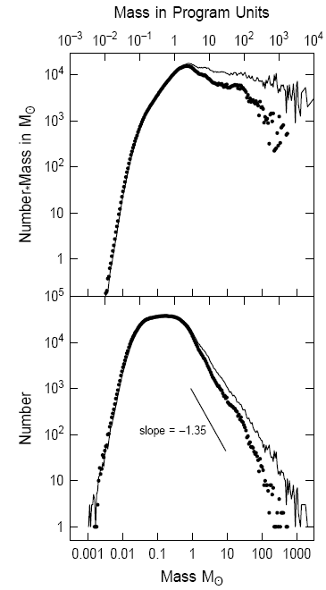
Fig. 4 – the bottom panel shows IMF simulations for two cases; the solid lines the model without timing constraints, and the dotted line is the model with timing constraints. The top panel shows the product of mass with IMF[2].

In conclusion, determining the actual maximum mass for a star is an incredibly complex endeavor. The range of maximum stellar masses is determined by the nature of the stars birthplace, including its composition, age, and location with respect to other astrophysical bodies. High-mass stars are the product of a series of conditions being met including the nature of the ISM, the composition of the stars birthplace, and the other objects that exist in its neighborhood. If the initial conditions are met, theoreticians have reasoned that the maximum stellar mass can be between 120-300 M_{solar}. Obviously this range will adjust for the three populations of stars. For Population I stars, the range will be the lowest, because these stars are created from outflow materials of older stars. Population I stars have a higher metallicity, an indicator of age of the material in the stars. Population II stars will have a higher range for the most massive stars due to the nature of their composition, which is from more primal material. Finally, speculated primordial Population III would be the most massive objects, near ~300-600 M_{solar} [7].
References

[1] Bonnell IA, Bate MR. 2005. MNRAS 356:1201-1221

[2] Elmegreen BG. 2000. Ap. J. 539: 342-351

[3] Elmegreen BG. 2006. Ap. J. 648:572-579

[4] Garmany CD, Conti PS, Chiosi C. 1982. Ap.J. 263:777-790

[5] Massey P, Johnson KE, Eastwood K. 1995. Ap. J. 454:151-71

[6] Oey MS, Clarke CJ. 2005. Ap. J. Lett. 620:L43-46

[7] Omukai K, Palla F. 2003. Ap.J. 589:677-87

[8] Salpeter EE. 1955. Ap. J. 121:161-67

[9] Zinnecker H, Yorke H. Annu. Rev. Astrophys. 2007. 45:481-563.

