Stellar Rotation and Evolution
Rob Parks

1. Introduction

Stellar rotation is an example of an astronomical domain that has been studied for several centuries and in which the developments are rather slow. A short historical review since the discovery of the solar rotation by Galileo Galilee is given by Tassoul (1978). Few of the early works apply to real stars, because in general gaseous configurations were not considered, and no account was given to radiative energy transport. The equations of rotating stars in radiative equilibrium were first considered by Milne (1923), von Zeipel (1924) and Eddington (1925); see also Tassoul (1990) for a more recent history. From the early days of stellar evolution, the studies of rotation and evolution have been closely associated. Soon after the first models showing that Main Sequence (MS) stars move farther into the giant and supergiant region (Sandage & Schwarzchild 1952), rotation was used as a major test for the evolution. Oke & Greenstein (1954) and Sandage (1955) found that the observed rotational velocities were consistent with the proposed evolutionary sequence.
Stellar evolution, like other fields of science, proceeds using as a guideline the principle of Occam's razor, which states that the explanation relying on the smallest number of hypotheses is usually the one to be preferred. Thus, as a result of the many well-known successes of the theory of stellar evolution, rotation was and is still generally considered only a second order effect. Over the recent years, however, a number of serious discrepancies between current models and observations have been noticed. They particularly concern the helium and nitrogen abundances in massive O and B type stars and in giants and supergiants, as well as in the distribution of stars in the HR diagram at various metallicities. The observations show that the role of rotation has been largely overlooked. All the model outputs (tracks in the HR diagram, lifetimes, actual masses, surface abundances, nucleosynthetic yields, supernova precursors, etc.) are greatly influenced by rotation; thus it turns out that stellar evolution is basically a function of mass, metallicity and angular velocity.
In this paper, I will begin by discussing some of basic physical effects caused by rotation including certain instabilities (Section 2). The next section (Section 3) will involve the role between mass loss and rotation. Section 4 will describe the observational constraints on the rotation of early type stars along with their evolutionary models while Section 5 will cover the same for late type stars.

2. Basic Physical Effects on Rotation

2.1 Hydrostatic Effects

In a rotating star, the centrifugal forces reduce the effective gravity according to the latitude and also introduce deviations from sphericity. The four equations of stellar structure need to be modified. The idea of the original method devised by Kippenhahn & Thomas (1970) and applied in most subsequent works (Endal & Sofia 1976; Pinsonneault et al 1989, 1990, 1991; Fliegner & Langer 1995; Heger et al 2000) is to replace the usual spherical eulerian or lagrangian coordinates with new coordinates characterizing the equipotentials. This method applies when the effective gravity can be derived from a potential, i.e. when the problem is conservative, which occurs for solid body rotation or for constant rotation on cylinders centered on the axis of rotation. If so, the structural variables P, T, ρ, ... are constant on an equipotential Ψ = Φ + ½Ω²r²sin²θ, where Φ is the gravitational potential, θ is the coaltitude, and Ω is the angular velocity. Thus the problem can be kept one-dimensional, which is a major advantage. However, the internal rotation generally evolves toward rotation laws that are non-conservative; in this case the above method is not physically consistent. Unfortunately, it has been and is still used by most authors.
A particularly interesting case of differential rotation is that with Ω constant on isobars (Zahn 1992). This case is called “shellular rotation”, and it is often approximated by Ω = Ω(r), which is valid at low rotation. It is supported by the study of turbulence in the Sun and stars (Spiegal & Zahn 1992, Zahn 1992). Such a law results from the fact that the turbulence is very anisotropic, with a much stronger, geostrophic-like transport in the horizontal direction than in the vertical one, where stabilization is favored by the stable temperature gradient. The horizontal turbulence enforces an essentially constant rotation rate on isobars, thus producing the preceding rotation law. The star models are essentially one-dimensional, which enormously simplifies the computations. Shellular rotation is likely to occur in fast as well as in slow rotators.
The equations of stellar structure can be written consistently for a differentially rotating star, if the rotation law is shellular. Then, the isobaric surfaces satisfy the same equation Ψ = const. As the equipotentials of the conservative case (Meynet & Maeder 1997), and thus the equations of stellar structure can be written as a function of the coordinate of an isobar, either in the lagrangian or eulerian form. Let us emphasize that in general the hydrostatic effects of rotation have only very small effects of the order of a few percent on the internal evolution (Faulkner et al 1968, Kippenhahn & Thomas 1970). Recent two-dimensional models including the hydrostatic effects of rotation confirm the smallness of these effects (Shindo et al 1997).
The above potential Ψ describes the shape of the star in the conservative case for the so-called Roche model, where the distortions of the gravitational potential are neglected. However, the stellar structure deviates from a surface given by Ψ = const in the case of non-conservative rotation law (Kippenhahn 1977).

2.2 The von Zeipel Theorem

The von Zeipel (1924) theorem is essential for predicting the distribution of temperature at the surface of a rotating star. It applies to the conservative case and states that the local radiative flux F is proportional to the local effective gravity g_{eff}, which is the sum of the gravity and centrifugal forces, if the star is not close to the Eddington limit,

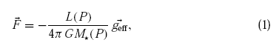

with M*(P) = M(1 – Ω²/2πG<ρ>); L(P) is the luminosity on an isobar, and <ρ> is the mean internal density. Thus the local effective temperature on the surface of a rotating star varies like T_{eff}(θ) ~ g_{eff}(θ)^{1/4}. This shows that the spectrum of a rotating star is in fact a composite spectrum made up of local atmospheres of different gravity and T_{eff}. If it is meaningful to define an average, a reasonable choice is to take T_{eff}⁴ = L/(σS(Ω)), where σ is Stefan's constant and S(Ω) is the total actual stellar surface. In the case of non-conservative rotation law, the corrections to the von Zeipel theorem depend on the opacity law and on the degree of differential rotation, but the corrections are likely to be small, i.e. ≤ 1% in current cases of shellular rotation (Kippenhahn 1977, Maeder 1999a). There are some discussions (Langer 1999; Langer et al 1999a) as to whether von Zeipel must really be used; we would like to emphasize that this is a mere and inescapable consequence of Newton's law and basic thermodynamics.

2.3 Transport of Angular Momentum and Chemical Elements

Inside a rotating star the angular momentum is transported by convection, turbulent diffusion, and meridional circulation. The equation of transport was derived by Jeans (1928), Tassoul (1978), Chaboyer & Zahn (1992) and Zahn (1992). For shellular rotation, the equation of transport of angular momentum in the vertical direction is (in lagrangian coordinates)

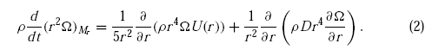

Ω(r) is the mean angular velocity at level r, U(r) is the vertical component of the meridional circulation velocity, and D is the diffusion coefficient resulting from the sum of the various turbulent diffusion processes. The factor 1/5 comes from the integration in latitude. If both U(r) and D are zero, we just have the local conservation of the angular momentum r²Ω = const for a fluid element in case of contraction or expansion. The solution of equation (2) gives the non-stationary solution of the problem. The rotation law is not arbitrarily chosen, but is allowed to evolve with time as a result of transport by meridional circulation, diffusion processes, and contraction or expansion. In turn, the differential rotation built up by the processes generates some turbulence and meridional circulation, which are themselves functions of the rotation law. This coupling provides feedback, and the self-consistent solution for the evolution Ω(r) must be found (Zahn 1992).
Some characteristic times can be associated to both the processes of meridional circulation and diffusion:

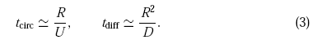

These timescales are essential quantities, because the comparison with the nuclear timescales will show the relative importance of the transport processes in the considered nuclear phases. Equation (2) also admits a stationary solution when one of the above characteristic times is short with respect to the nuclear evolution time, a situation that only occurs at the beginning of the MS:
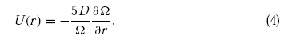

This equation (Randers 1941, Zahn 1992) expresses that the (inward) flux of the angular momentum transported by meridional circulation is equal to the (outward) diffusive flux of angular momentum. As a matter of fact, this solution is equivalent to considering local conservation of angular momentum (Urpin er al 1996).
Instead of equation (2), the transport of angular momentum by circulation is often treated as a diffusion process (Endal & Sofia 1978; Pinsonneault et al 1989, 1990; Langer 1991a; Fliegner & Langer 1995; Chaboyer et al 1995a,b; Heger et al 2000). We see from equation (2) that the term U(advection) is functionally not the same as the term D(diffusion). Physically, advection and diffusion are quite different. Diffusion brings a quantity from where there is a lot of this q quantity to places where there is little. This is not necessarily the case for advection; for example, the circulation of money in the world is not a diffusive process, but an advective one. Let us make it clear that circulation with a positive value of U(r) i.e. Rising along the polar axis and descending at the equator, is in fact making an inward transport of angular momentum. If this process were treated as a diffusive function of ∂Ω/∂r, even the sign of the effect may be wrong.
A differential equation like equation (2) is subject to boundary conditions at the edge of the core and at the stellar surface. At both places, this condition is usually ∂Ω/∂r = 0, with in addition the assumptions of solid body rotation for the convective core and U = 0 at the surface (Talon et al 1997, Denissenkov et al 1999). If there is magnetic coupling at the surface (Hartmann & Noyes 1987; Pinsonneault et al 1989, 1990; Pinsonneault 1997) or mass loss by stellar winds, the surface condition must be modified accordingly (Maeder 1999a). Various asymptotic regimes for the angular momentum transport can be considered (Zahn 1992) depending on the presence of a wind or without magnetic coupling.

2.4 Transport of Chemical Elements

The transport of chemical elements is also governed by a diffusion-advection equation like equation (2) (Endal & Sofia 1978; Schatzman et al 1981; Langer 1991a, 1992; Heger er al 2000). However, if the horizontal component of the turbulent diffusion is large, the vertical advection of the elements (and not that of the angular momentum) can be treated as a simple diffusion (Chaboyer & Zahn 1992) with a diffusion coefficient D_{eff},

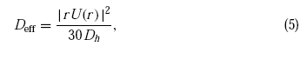

where D_{h} is the coefficient of horizontal turbulence, for which an estimate D_{h} = |rU(r)| (Zahn 1992). Equation (5) expresses that the vertical advection of chemical elements is severely inhibited by the strong horizontal turbulence characterized by D_{h}. Thus, the change of the mass fraction X_{i} of the chemical species i is simply

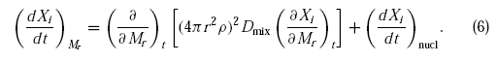

The second term on the right accounts for composition changes resulting from nuclear reactions. The coefficient D_{mix} is the sum D_{mix} = D + D_{eff}, where D is the term appearing in equation (2) and D_{eff} accounts for the combined effect of advection and horizontal turbulence. The characteristic time for the mixing of chemical elements is therefore

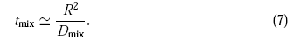

Noticeably, the characteristic time for chemical mixing is not t_{circ} given by equation (3), as has been generally assumed (Schwarzchild 1958). This makes the mixing of chemical elements much slower, since D_{eff} is very much reduced. In this context, we recall that several authors have reduced by arbitrary factors (up to 30 or 100) the effect of the transport of chemicals in order to better fit the observed surface compositions (Pinsonneault 1989, 1991; Chaboyer et al 1995a,b; Heger et al 2000). This is no longer necessary with the more appropriate expressions given above.

2.5 Meridional Circulation

Meridional circulation arises from the local breakdown of radiative equilibrium in a rotating star (Vogt 1925, Eddington 1925). In a uniformly rotating star, the equipotentials are closer to each other along the polar axis than the equatorial axis. Thus, according to von Zeipel's theorem, the heating on an equipotential is generally higher in the polar direction than in the equatorial direction, which thus drives a large-scale circulation rising at the pole and descending at the equator. This problem has been studied for about 75 years (see reviews by Tassoul 1978 or Zahn 1983). The classical formulation (Sweet 1950; Mestel 1953, 1965; Kippenhahn & Weigert 1990) for rigid rotation predicts a value of the vertical velocity of the Eddington-Sweet circulation

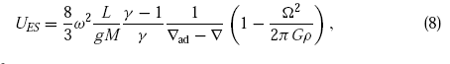

with ω² = Ω²r³/(GM_{r}) the local ratio of centrifugal force to gravity and γ the ratio of specific heats c_{p}/c_{v}. The term Ω²/(2πGρ), often called the Gratton-Opik term (Tassoul 1990), predicts that U_{ES} becomes negative at the stellar surface because of the presence of the term 1/ρ. This means an inverse circulation, i.e. Descending at the pole and rising at the equator. The dependence in 1/ρ also makes U(r) diverge at the surface. This has led to some controversies on what is limiting U(r) (Tassoul &Tassoul 1982, 1995; Zahn 1983; Tassoul 1990). The timescale for circulation mixing defined by equation (3) becomes, with the above Eddington-Sweet velocity,

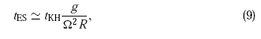

where g is the surface gravity and R is the stellar radius. Even for the modest rotation velocities, t_{ES} is much shorter than the MS lifetime (Schwarzchild 1958), so that most stars should be mixed, if this timescale were applicable. However, the presence of μ-gradients was not taken into account in the above expressions. When this is done, rotation is found to allow circulation above a certain rotation limit that depends on the value of the μ-gradient (Mestel 1965; Kippenhahn 1974, Kippenhahn & Weigert 1990). The balance of rotation and μ-gradients has been considered in Vauclair (1999).
The velocity of the meridional circulation in the case of the shellular rotation was derived by Zahn (1992), who considered the effects of the latitude-dependent μ-distribution (Mestel 1953, 1965). Even more important are the effects of the vertical μ-gradient and of the horizontal turbulence (Maeder & Zahn 1998). Contrary to the conclusions of the previous works, the μ-gradients were shown not to introduce a velocity threshold for the existence of the circulation, but to progressively reduce the circulation when the vertical μ-gradient increases. We then have

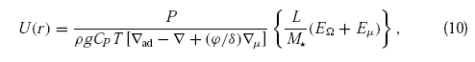

where P is the pressure, c_{p} is the specific heat at constant pressure, and E_{Ω} and E_{μ} are terms depending on the Ω- and μ-distributions respectively, up to the third-order derivatives. Because the derivative of U(r) appears in equation (2), we see that the consistent solution to the problem is of fourth order (Zahn 1992). This makes the numerical solution difficult (Talon et al 1997). Whereas the classical solution predicts an infinite velocity at the interface between a radiative and a semiconvective zone with an inverse circulation in the semiconvective zone, equation (10) gives a continuity of the solution with no change in sign. In evolutionary models, the term del μ in equation (10) may be one or two orders of magnitude larger than del_{ad} – del in some layers, so that U(r) may be reduced by the same ratio. This considerably increases the characteristic time t_{circ} with respect to the classical estimate t_{ES}.

2.6 Instabilities and Transport

The subject of the instabilities in moving plasmas is a field in itself. Here we limit ourselves to the short description of the main instabilities currently considered influential in the evolution of MS stars.

2.6.1 Convective and Solberg-Hoiland Instability

In a rotating star, the Ledoux or Schwarzchild criteria for convective instability should be replaced by the Solberg-Hoiland criterion (Kippenhahn & Weigert 1990). This criterion accounts for the difference of the centrifugal force for an adiabatically displaced fluid element; the condition for dynamical stability is

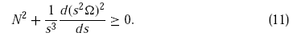

The Brunt-Vaisala frequency N² is given by N² = (gδ/H_{P})(del_{ad} – del + (φ/δ)del_{μ}), where the various symbols have their usual meaning (Kippenhahn & Weigert 1990), and the term s is the distance to the rotation axis. For no rotation, the Ledouz criterion is recovered. If the thermal effects are ignored, we just cover Rayleigh's criterion for stability, which states that the specific angular momentum s²Ω must increase with the distance to the rotation axis. For displacements parallel to the rotation axis, convective instability occurs when N² < 0. For displacements perpendicular to the rotation axis, the stability is in general reinforced. Thus, criterion (cf. Ledoux 1958). In the absence of rotation, a zone located between the places where del = del_{ad} + del_{μ} and del = del_{ad} is called semiconvective. There, non-adiabatic effects can drive growing oscillatory instabilities (Kippenhahn & Weigert 1990). An appropriate diffusion coefficient describing the transport is such zones was derived by Langer et al (1983). However, there is no diffusion coefficient yet available for semiconvective mixing in the presence of rotation.
The assumption of solid body rotation is generally made in convective regions, owing to the strong turbulent coupling. However, collisions or scattering of convective blobs influence the rotation law in convective regions (Kumar et al 1995). Solid body rotation only occurs for an isotropic scattering. For some forms of anisotropic scattering, an outward rising rotation profile such as that observed in the Sun can be produced. Two dimensional models of rotating stars (Deupree 1995,1998) also show that the angular velocity in convective cores is not uniform, but it decreases with distance from the center and is about constant on cylinders. A considerable overshoot is obtained by Deupree (1998) and amounts to about 0.35 H_{P}, where H_{P} is the local pressure scale height. Similar conclusions were obtained by Toomre (1994), who also found penetrative convection at the edge of the convective core of rotating A-type stars. The very large Reynolds number characterizing stellar turbulence prevents direct numerical simulations of the Navier-Stokes equation, so that some new specific methods have been proposed to study convective turbulence (Canuto 1994; Canuto et al 1996; Canuto & Dubovikov 1997) and its interplay with differential rotation (Canuto et al 1994; Canuto 1998); these last results have not yet been applied to evolutionary models in rotation.

2.6.2 Shear Instabilities: Dynamical and Secular

In the radiative zone, shear caused by differential rotation is likely to be a very efficient mixing process. Indeed shear instability grows on a dynamical timescale that is of the order of the rotation period (Zahn 1992, 1994). Stability is maintained when the Richardson number Ri is larger than a critical value Ri_{cr}

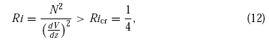

where V is the horizontal velocity and z is the vertical coordinate. Equation (12) means that the restoring force of the density gradient is larger than the excess energy 1/4(dV/dz)² present in the differentially rotating layers (Chandrasekhar 1961). In equation (12), heat exchanges are ignored and the criterion refers to the dynamical shear instability (Endal & Sofia 1978; Kippenhahn & Weigert 1990).
When thermal dissipation is significant, the restoring force of buoyancy is reduced and the instability occurs more easily (Endal & Sofia 1978); the timescale is longer, however, because it is the thermal timescale. This case is sometimes referred to as secular shear instability. For small thermal effects (Pe << 1), a factor equal to Pe appears as multiplying N² in equation (12) (Zahn 1974). The number Pe is the ratio of the thermal cooling time to the dynamical time, i.e. Pe = vl/K, where v and l are the characteristic velocity and length scales, and K = (4acT³)/(3c_{P}κρ²) is the thermal diffusivity. Pe varies typically from 10⁹ in deep interiors to 10⁻² in outer layers (Cox & Giuli 1968). For general values of Pe, a more general expression of the Richardson's criterion can be found (Maedar 1995; Maedar &Meynet 1996); it is consistent with the case of low Pe treated by Zahn (1974). The problem of the Richardson criterion has also been considered by Canuto (1998), who suggests that for Pe > 1, i.e. Negligible radiative losses Ri_{cr} ~ 1 and for Pe < 1, i.e. Important radiative losses Ri_{cr} ~ Pe⁻¹. Thus, similar dependences with respect to Pe are obtained, but Canuto (1998) finds that turbulence may exist beyond the ¼ limit in equation (12).
Many authors have shown that the μ-gradients appear to inhibit the mixing too much with respect to what is required by the observations (Chaboyer et al 1995a,b; Meynet & Maeder 1997). Changing Ri_{cr} from ¼ to 1 does not solve the problem, since the difference is a matter of one or two orders of magnitude. For example, instead of using a gradient del_{μ}, some authors write f_{μ}del_{μ} with an arbitrary factor f_{μ} = 0.05 or even smaller (Heger et al 2000; Chaboyer et al 1995a,b). Most of the zone external to the convective core, where the μ-gradient inhibits mixing, is in fact semiconvective and is thus subject to thermal instability anyway. This has led to the hypotheses that the excess energy in the shear is degraded by turbulence on the thermal timescale, which changes the entropy gradient and consequently the μ-gradient (Maeder 1997). This gives a diffusion coefficient D_{shear}, which tends toward the diffusion coefficient for semiconvection by Langer et al (1983) when shear is negligible and toward the value D_{shear} = (K/N²)(Ω d ln(Ω)/d ln(r))² given by Zahn (1992) when semiconvection is negligible. Another proposition was made by Talon & Zahn (1997), who took into account the homogenizing effect of horizontal diffusion on the restoring force produced by the μ-gradient. This also reduces the excessive stabilizing effect of the μ-gradient. Both of the above suggestions lead to an acceptable amount of mixing in view of the observations. We stress that the Reynolds condition D_{shear} ≥ 1/3νRe_{c} must be satisfied when the medium is turbulent, where Re_{c} is the critical Reynolds number (Zahn 1992; Denissenkov et al 1999) and ν is the total viscosity (radiative + molecular).
Globally, we may expect the secular instability to work during the MS phase, where the Ω-gradients are small and the lifetimes are long, whereas the dynamical instability could play a role in the advanced stages.

2.6.3 Other Instabilities

Baroclinicity, i.e. The non-coincidence of the equipotentials and surface of constant ρ, generates various instabilities in the case of non-conservative rotation laws. Some instabilities are axisymmetric, like the GSF instability (Goldreich & Schubert 1967, Fricke 1968). The GSF instability is created by fluid elements displaced between the directions of constant angular momentum and the rotation axis. Stability demands a uniform or constant rotation on cylinders, which is incompatible with shellular rotation. The GSF instability thus favors solid-body rotation, on a timescale of the order of the meridional circulation (Endal & Sofia 1978). This instability is inhibited by the μ-gradients (Knobloch & Spruit 1983), nevertheless Heger et al (2000) find that it plays a role near the end of the helium-burning phase. Another axisymmetric instability is the ABCD instability (Knobloch & Spruit 1983). Fluid elements displaced between the surfaces of constant P and T create the ABCD instability, a kind of horizontal convection. The ABCD instability is oscillatory, and its efficiency is difficult to estimate now. Non-axisymmetric instabilities, such as salt-fingers, may also occur (Spruit & Knobloch 1984). They are not efficient when rotation is low; however, in the case of fast rotation they may occur everywhere in rotating stars, so that one-dimensional models are likely to be an unsatisfactory idealization in this case.
The study of the transport of angular momentum by gravity waves has been stimulated by the finding of an almost solid body rotation for most the radiative interior of the Sun (Schatzman 1993, Montaban 1994, Kumar & Quataert 1997, Zahn et al 1997, Talon & Zahn 1998). Gravity waves are supposed to transport angular momentum from the external convective layers to the radiative interior. However, Ringot (1998) has recently shown that quasi-solid rotation of the radiative zone of the Sun cannot be a direct consequence of the action of gravity waves. Thus, even the for the Sun the importance of gravity waves remains uncertain.

3. Mass Loss and Rotational

Mass loss by stellar winds is a dominant effect in the evolution of upper MS stars. The mass loss rates currently applied in stellar models are based on the observations of de Jager et al 1988, Lamers & Cassinelli 1996. A significant growth of the mass flux of OB stars with rotation, i.e. By 2-3 powers of 10, was found by Vardya (1985). Nieuwenhuijzen & de Jager (1988) suggested that the correlation found by Vardya mainly reflects the distributions of the mass loss rates Mdot and of the rotational velocities v_{rot} over the HR diagram. After trying to disentangle the effects of L, T_{eff}, and v_{rot} they found that the Mdot-rates seem to increase only slightly with rotation for O and B type stars. The result by Vardya might not be incorrect; when data for OB stars by Nieuwenhuijzen & de Jager (1988) are considered, a correlation of the mass fluxes with v_{rot} is noticable. These authors also point out that the equatorial Mdot-rates of Be stars are larger by a factor 10². Since Be stars are essentially B stars with fast rotation, a single description of the large changes of the Mdot-rates from low to the high values of v_{rot} should be considered.
On the theoretical side, Pauldrach et al (1986) and Poe & Friend (1986) found a very weak change of the Mdot-rates with v_{rot} for O stars: the increase amounts to about 30% for v_{rot}=350 km/s. Friend & Abbot (1986) found an increase of the Mdot-rates, which can be fitted by the relation (Langer 1998, Heger & Langer 1998)

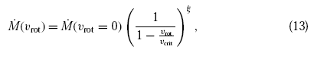

with ξ = 0.43; this expression is often used in evolutionary models.
The previous wind models of rotating stars are incomplete because they do not account for the von Zeipel theorem. The gravity darkening at the equator leads to a reduction of the equatorial mass flux (Owocki et al 1996, Owocki & Gayley 1997,1998). This leads to very different predictions for the wind morphology than those of the current wind compressed disk model by Bjorkman& Cassinelli (1993), which is currently advocated to explain disk formation. Equatorial disks may form quite naturally around rotating stars, however. The theory of radiative winds, with revised expressions of the von Zeipel theorem and of the Eddington factor, has been applied to rotating stars (Maeder 1999a). There are two main sources of wind anisotropies: (1) the g_{eff}-effect, which favors polar ejection, since the polar caps of a rotating star are hotter, and (2) the opacity or κ-effect, which favors the equatorial ejection when the opacity is large enough at the equator as a result of an opacity law that increases rapidly with decreasing temperature. In O type stars, because opacity results mainly from the T-independent electron scattering, the g_{eff}-effect is likely to dominate and to raise a fast, highly ionized polar wind. In the B type and later stars, where a T-growing opacity is present in the external layers, the opacity effect should favor a dense equatorial wind and ring formation, with low terminal velocities and low ionization.
The so-called B[e] stars (Zickgraf 1999) are known to show both a fast, highly ionized polar wind and a slow, dense, low ionization equatorial ejection, and they may be the template of the g_{eff} and κ effects. At some values of T, the ionization equilibrium of the stellar wind changes rather abruptly, as do the opacity and the force-multipliers that characterize the opacity (Kudritzki et al 1989, Lamers 1997, Lamers 1999). Such transitions, which Lamers calls the bi-stability of stellar winds, may favor strong anisotropies of the winds, and even create some symmetrical rings at the latitude where an opacity peak occurs on the T-varying surface of the star.
It could be thought at first sight that wind anisotropies have no direct consequences for stellar evolution. This in not at all the case. Like magnetic coupling for low-mass stars, the anisotropic mass loss selectively removes the angular momentum (Maeder 1999a) and influences further evolution. Winds through polar caps, as are likely in O stars, remove very little angular momentum, whereas equatorial mass loss removes considerable angular momentum from the stellar surface.

4. Early Type Stars

4.1 Effects of Rotation on the Observable Parameters

The most conspicuous effect of rotation is to distort a star into an oblate configuration. This is well illustrated in Figure 1, although it is not known whether such high degrees of differential rotation are present in real stars. Yet, it is these departures from sphericity and the luminosity changes that are of paramount importance for the observable effects of rotation on the radiation emanating from a star. A barotropic model (one in which surfaces of constant temperature and pressure coincide) with a radiative envelope has an emergent flux |F| that varies in proportion to the surface effective gravity g_{eff}. Since this quantity is smaller at the equator than at the pole, both the local effective temperature and surface brightness are, therefore, lower at the equator than at the poles. This implies in turn that the various magnitudes and color indices of a rotating star will be functions of the aspect angle i between the line of sight and the rotation axis.
The theoretical problem divides naturally into three parts: (1) Building an interior model so that the effective temperature and gravity become known as functions of latitude on its free surface, (2) computing energy spectrum of radiation as a function of aspect angle when a suitably realistic model atmosphere is fitted at each point of the free surface, and (3) integrating the emergent flux to obtain the usual photometric parameters for each aspect angle. Figures 1 and 2 illustrate the results obtained by Maeder & Peytremann (1970), who have computed the energy spectrum of radiation for uniformly rotating stars 5 M_{sun}, 2 M_{sun}, and 1.4 M_{sun}. Each rotational track represents configurations ranging from the nonrotating model to the uniformly rotating model for which Ω/Ω_{cr} = 0.99, where Ω_{cr} is the angular velocity at breakup rotation. For each mass, different values of the inclination angle i have been considered, with the aspect angle increasing from i = 0° (“pole-on” stars) to i = 90° (“equator-on” stars). For the 2 M_{sun} models, the percentage of stars under the random-orientation hypotheses is also indicated. (This is, of course, valid for all masses.) We observe that a pole-on star appears brighter than a nonrotating star of the same mass, but has almost the same color. This is so because one is directly facing the brighter polar regions as well as a larger projected area resulting from the star's oblateness. Figure 1 also shows that an equator-on star star appears fainter and considerably redder than a nonrotating star of the same mass. The reason lies in the fact that limb darkening reduces the brightness of the polar regions while gravity darkening makes the equatorial belt cooler.
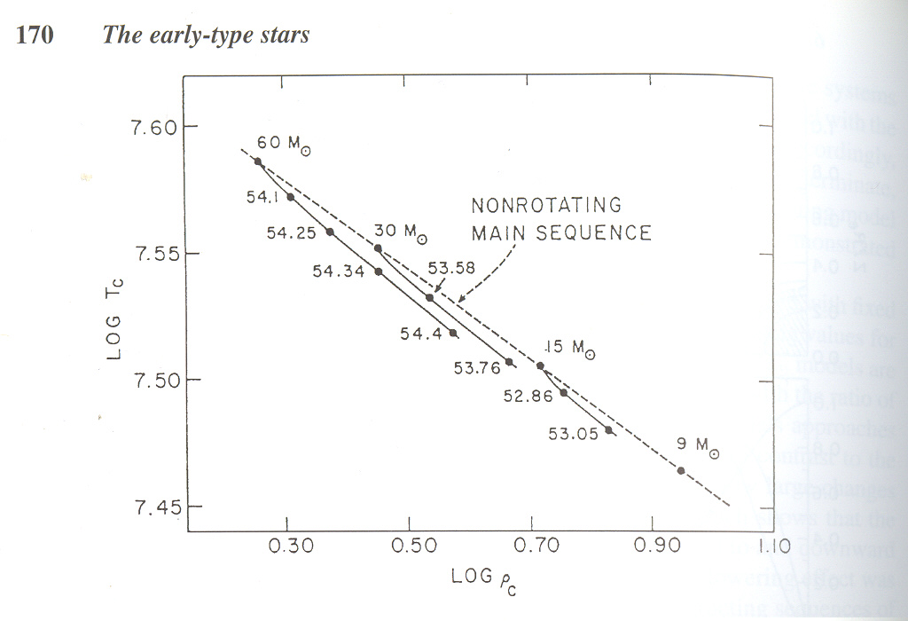Figure 1: Sequences of rotating models with increasing angular momentum J
Figure 2: Color-magnitude diagram with rotational tracks for 5 Msun, 2 Msun and 1.4 Msun, and various angles
How do these theoretical results compare with the available observational data for normal MS stars? By comparing their uniformly rotating models with various observed quantities, Maeder & Peytremann (1970) found that there was agreement with observation for stars earlier than about spectral type A7 but the later types showed effects at least two times larger than predicted by solid-body rotation. If so, then what rotation law do upper MS stars actually follow? The problem has been considered by Smith (1971), who made a statistical study of the data available for rotating stars in the Praesepe and Hyades clusters. In agreement with other works, it is found that these stars seem not to be rotating uniformly. Unfortunately, a detailed study of the errors involved also shows uncertainties to be such that the observations cannot be said to support any particular law of nonuniform rotation. More recently, Collins and Smith (1985) have made use of detailed stellar atmosphere models to compute the photometric effect of differential as well as rigid rotation in the A type stars. Their analysis confirms the known qualitative result that differential rotation produces large scatter in the color-magnitude diagram than does uniform rotation. As was shown by the authors, however, photometry alone can only put rather eak constraints on the angular momentum distribution of the upper MS stars. This precludes any more definite conclusion about the nature of the rotation law in these stars.
Let us next consider the modifications brought by rotation on the age estimates of open star clusters. As we know, the age of a cluster is obtained from its color-magnitude diagram fitting the observed sequence in the turnoff region with isochrones derived from nonrotating stellar models. The effects of rotation on age estimates are essentially of two kinds: (1) aspect effects on the color and magnitude of each star belonging to the cluster, and (2) structural effects on the models that are used to draw the theoretical isochrones. Both effects have been considered by Maeder (1971) under the assumption of uniform rotation on and above the MS. His analysis indicates that the structural effects of uniform rotation on age estimates are negligible in comparison to the aspect effects. However, because the displacement of a rotating star to the right of the MS can mimic the displacement due to evolution, neglecting the aspect effects leads to an overestimate in age that may reach up to 70% for clusters with the most rapidly rotating stars. In fact, Maeder has estimated that the age overestimates caused by the neglect of rotation reach about 60-70% for α Persei and the Pleiades. By contrast, the ages of the older clusters undergo very little changes approximately 10-20%, because the stars in the turnoff region are less massive and so are rotating more slowly.
It is evident that neither theoretical considerations nor observations of the continuum can give a clear expectation for the actual rotation law in the upper MS stars. To what extent can the study of spectral lines yield useful information about the degree of surface differential rotation in these stars? The major effects of axial rotation on spectral lines is to broaden them, with no change in the equivalent width; the amount of the broadening depends upon the degree of axial rotation and the aspect angle i. In principle, the extent of surface differential rotation and macroturbulence in a star can be determined from the departures of observed line profiles and concomitant Fourier transforms from their standard theoretical counterparts. Attempts to extract this information from line profiles and in the Fourier domain have been attempted (Stoeckley & Buscombe 1987, Gray 1977). Although these and related studies have not yet yielded any definite information on the surface velocity field of a star, Gray's results strongly suggest that differential rotation does not exist or is small in early type stars. More recently, Collins & Truax (1995) have investigated the extent to which the actual velocity field of these stars can be determined by the information contained within a spectral line profile or its Fourier transform. It is found that one may use the classical model of a rotating star to determine the projected rotational speeds as long as one does not expect accuracies greater than 10% under ideal conditions, with significantly larger errors for stars exhibiting extreme rotation. Accordingly, the use of the classical model as a probe of surface differential rotation and macroturbulence in a star remains problematic at best.

4.2 Rotation of Evolved Stars

Among the many problems that beset the theory of rotating stars, the redistribution of angular momentum in stellar interiors during evolution is by far the least understood. As we know, the post-MS evolution of a star is accompanied by a strong contraction of its helium core and by a corresponding expansion of the surrounding envelope. Unless there exists a very efficient transport of angular momentum from the core to the envelope, it is evident that the former has to spin up appreciably while at the same time the latter must spin down. The decrease in surface rotation as a star evolves away from the MS has been known for several decades. Unfortunately, to compute the gross changes caused by rotation in evolving stars, we are faced with two largely unresolved questions: Is the total angular momentum J of a star conserved or lost during is post-MS evolution? And is there an effective means to redistribute the specific angular momentum r²Ω during the evolution? The most reliable calculations are those of Endal & Sofia (1979), who have considered different cases of angular momentum. At the time, their theoretical surface rotation velocities for red giant models were in agreement with the observed rotation rates for the K giants, so that there was apparently no need to invoke angular momentum losses among these stars.
A different picture emerged, however, when Gray's (1982) Fourier analysis of high signal-to-noise ratio data showed the existence of a discontinuity in rotation for luminosity class III giants. This sudden drop takes place between spectral types G0 III and G3 III. A similar rotational discontinuity was also seen in a sample of luminosity class IV subgiants (Gray & Nagar 1985). Near G0 IV, a sudden drop in rotation was observed with advanced spectral type, in complete analogy to the drop seen at G0 III in the giants. More recently, a systematic survey of about 2000 evolved stars was carried out (de Mederious & Mayor 1991), covering the spectral range from middle F to middle K of luminosity classes IV, III, II and Ib. Figures 3 and 4 illustrate the vsini measurements of their sample of stars for each luminosity class located at F8 IV, G0 III, F9 II and near F9 Ib; this corresponds to the (B-V) colors 0.55, 0.77, 0.65, and about 0.70 respectively.
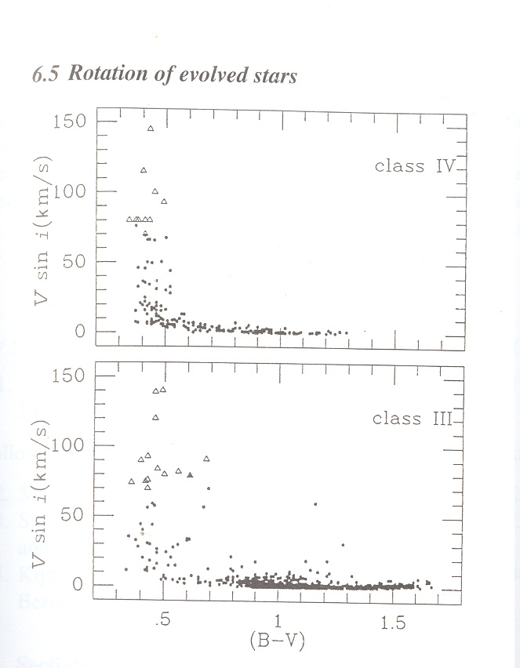Figure 3: Projected equatorial velocities as functions of (B-V) color.
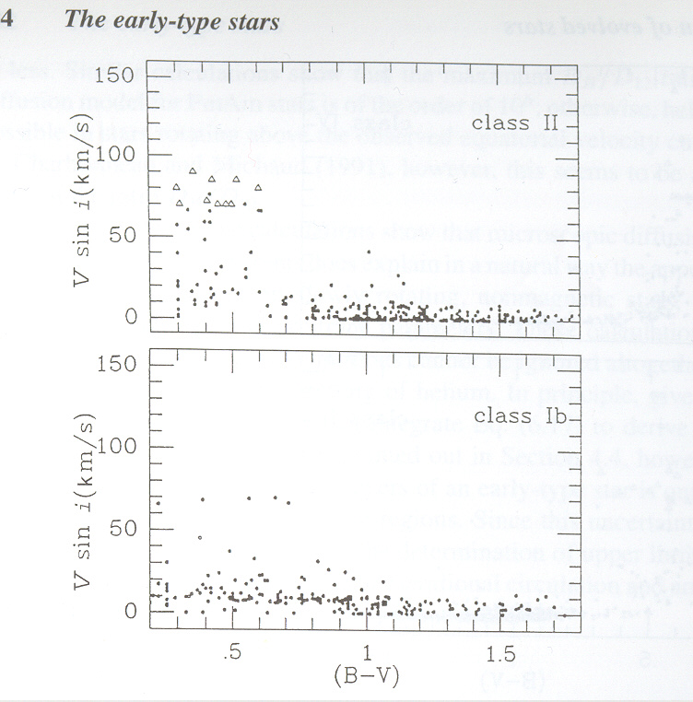Figure 4: Projected equatorial velocities as functions of (B-V) color
Note the wide range of vsini values on the left side of the discontinuity for all luminosity classes. This large spreads seem to reflect the broad distributions of rotation rates along the MS. Note also that the spread in vsini values on the left of the cutoff decreases with increasing luminosity. In fact, the supergiant stars show no sudden decrease in rotation, and there is still a large fraction of slow rotators on the left of the discontinuity. This result strongly suggests that the origin of the rotational discontinuity is not the same for all classes.
As was originally suggested by Gray in the 1980's, the rotational discontinuity for the subgiant and giant stars can be interpreted as a result of a strong magnetic braking due to the deepening of their outer convective envelopes at some point in their evolution. To be specific, since the evolution of these stars carries them from hotter to cooler spectral types, a plot of rotation versus (B-V) color delineates the time sequences of their rotational changes. As their progenitors evolve off the main sequence, the evolutionary increase in the moment of inertia slowly reduces the rotation to the values attained on the left of the discontinuities. Sudden changes seen near spectral types G0 IV and G0 III occur because the evolutionary deepening of the convective envelope has become sufficient to sustain dynamo activity. Thence, a small amount of material escaping from the star's surface is caught in the open field lines of the dynamo-generated magnetic material. In short, the star develops an external magnetic brake that rapidly decelerates the rotation of at least its outer convective envelope.
An important piece of evidence in support of Gray's mechanism comes from the work of Simon & Drake (1989), who have shown that subgiant and giant stars undergo a sudden decrease in chromospheric activity at spectral types G0 IV and G0 III, which correspond to the (B-V) colors 0.6 and 0.7, respectively. The fact that in both cases the observed decline in UV emission coincides with the sharp decrease in surface rotation rates strongly suggests that Gray's mechanism is indeed operative in these stars. As they noted, this joint decay in activity and rotation marks a transformation from acoustic heating in the early F type stars to a magnetically controlled action by means of stellar winds. Detailed calculations by Schrijer & Pols (1993) further indicate that the decrease in the observed rotational velocities of subgiants and giants is stronger than expected from the increase in moment of inertia alone, so that loss of angular momentum through magnetically channeled stellar winds must be sustained between the onset of convection and just beyond the upturn onto the giant branch. For the most luminous classes, however, the discontinuity in rotational velocities is probably the result of another evolutionary effect.

5. Late Type Stars

5.1 Schatzman's Braking Mechanism

The key characteristic that will come into play in this section for late type stars is the possession of a large convective envelope surrounding a radiative core. This stellar configuration, as discussed above, leads to the generation of magnetic fields via a dynamo process. These magnetic fields couple themselves to the stellar winds outflowing from the star and produce an effective magnetic brake. The relevance of magnetic braking for stars have deep surface convection zones was first recognized by Schatzman (1962). Very briefly, it is assumed that these stars generate episodic mass ejections that act as an expanding plasma in a large-scale magnetic field. As material is ejects from the activity zones, the magnetic fields can enforce approximate corotation until the gas has moved out to distances much larger than the star's radius. Beyond this region, because the magnetic stresses become less and less important, the outflowing material can thus leave the star, with each mass element carrying away its angular momentum. As we shall see below, if the gas is kept corotating with the star a quite small amount of mass loss yields proportionally a much greater loss of angular momentum than matter retaining the angular momentum of the star's surface. Given the efficiency of this mechanism for extracting angular momentum from stars with outer convective zones, the break in the MS rotational velocities can be explained as follows. Since high-mass stars spend relatively little time in the convective phase, magnetic braking is therefore virtually inoperative for these stars. Hense, they suffer very little loss of angular momentum during the pre-MS contraction. In contrast, low mass stars have a more important convective phase since they retain an outer convection zone all the way to the MS. Magnetic braking can thus operate during the entire pre-MS contraction and during much of their MS lifetimes. Since the rapid drop in rotational velocity is seen at approximately the point where MS stars develop subphotospheric convection zones (F0), it follows that angular momentum loss preferably occurs in the low-mass stars, thus causing the observed rotational discontinuity in the F star region. As was shown by Wolf & Simon (1997), recent data strongly suggests that this sharp decrease in mean equatorial velocity along the MS, from about 1.6 M_{sun} down to about 1.3 M_{sun}, has already been imposed during the pre-MS phase of stellar evolution. For masses less then 1.3 M_{sun}, however, their analysis indicates that further loss of angular momentum occurs rapidly during the MS evolution so that, by the age of the Hyades (~ 600 Myr), mean equatorial velocities for stars in the spectral range F8V – K5V are remarkably uniform at any given mass and decline from about 11 km/s at F8V to about 4 km/s at K5V.

5.2 Rotational evolution models

Since the early 1990s, much theoretical effort has been expended in trying to understand the rotational history of a low mass star, both before and during the MS phase. Notably, MacGregor & Brenner (1991) have developed a particularly simple description of the transport of angular momentum within the interior of a solar-type star. In this section, I shall briefly describe their model, its use in conjunction with a suitable parameterization for the angular momentum loss resulting from magnetized stellar winds and some of the numerical results obtained by Keppens, MacGregor and Charbonneau (1995).
Broadly speaking, their approach to constructing an evolutionary sequence is to simplify matters by separating computation of the rotational evolution from that of the internal structural evolution. Accordingly, we shall assume that the effects of rotation on internal structure are small, so that an evolutionary track for a spherical star of the same mass can be used to calculate the star's radius R, the radius of the convective zone base R_{conv}, the mass of the radiative core M_{core}, and the moment of inertia, I_{core}, and I_{conv,} of the core and envelope. We shall further assume that the radiative core and the convective envelope each rotate rigidly, although not necessarily at the same rate. If Ω_{core} and Ω_{conv} are the angular velocities of the core and envelope, then the angular momenta of these regions are J_{core} = I_{core}Ω_{core} and J_{conv} = I_{conv}Ω_{conv}. With these assumptions, the equations governing the time evolution of these angular momenta can be derived by considering the processes by means of which angular momentum is redistributed and lost.
In Figure 5 we illustrate the influence of the model parameters on the rotational evolution of a single star. Panels A, B and C are calculated for a 1 M_{sun} star; they depict the effect of varying the dynamo prescription, the coupling time scale τ_{c}, and the initial equatorial velocity v_{eq}. Panel D illustrates the rotational evolution of stars of different mass. Obviously, an important feature of these solutions is the convergence of rotation rates after a time of the order of 1 Gyr. It is also apparent that the rotational memory of a solar-type star is effectively lost at the age of the present-day Sun. In fact, all models considered end up rotating at nearly the present-day solar rotation rate (Ω_{sun} ≈ 3 x 10⁻⁶ s⁻¹), with essentially no internal differential rotation.

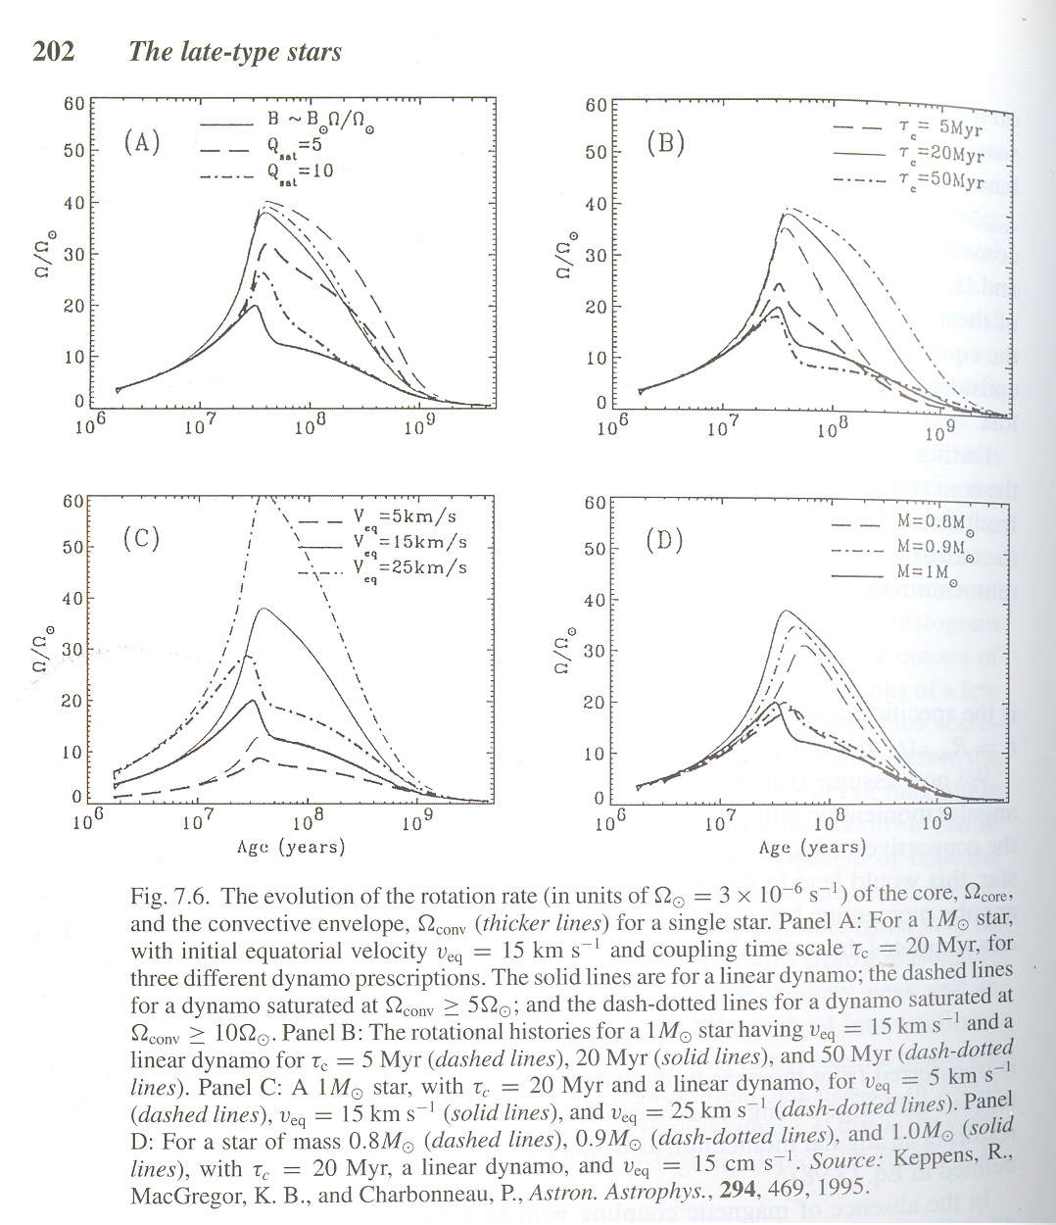Figure 5: The evolution of the stellar core and convective envelope
Panel A of Figure 5 shows how the phenomenological dynamo prescription influences the rotation evolution of a 1 M_{sun}, with v_{eq} = 15 km/s and τ_{c} = 20 Myr. The solid line corresponds to a linear dynamo, that is, a dynamo for which the strength of the mean coronal magnetic field increases linearly with rotation. The dashed lines and dash-dotted lines correspond to saturated dynamos, in which the mean coronal field saturates when the star rotates faster than, respectively, 5 and 10 times the present-day solar rotation rate. One readily sees that dynamo saturation reduces the angular momentum loss from the stellar wind since a lower field strength at the base of the corona causes less efficient magnetocentrifugal acceleration of the plasma. The angular momentum carried away by the stellar wind is therefore reduced, so that higher rotational velocities are achieved and sustained for a larger time. As was shown by Keppens and coworkers, a linear dynamo produces adequate spin-down early in the evolution but fails to produce sufficiently rapid rotators at the ages of α Persei and the Pleiades. Their analysis also shows that a saturated dynamo can explain the observed large spreads in rotation rates but the level of saturation is constrained by the requirement of achieving spin-down to slow rotation by the Hyades age.

6. Conclusion

Hopefully this has been instructive on the basics of stellar rotation. This paper should not only have illustrated how much work is still needed to fully understand this fundamental stellar parameter, but also how the inclusion of rotation in stellar evolutionary models is necessary if said models are to produce accurate results.
Further progress requires more studies of the physical effects of rotation, in particular of the various instabilities that can produce mixing of the elements and transport of angular momentum, both in the early and advanced phases of evolution. The influence of rotation on mass loss is also critical.

Literature Cited

Bjorkman JE, Cassinelli JP. 1993, Ap. J. 409:429-49
Canuto VM. 1994, Ap. J. 428:729-52
Canuto VM. 1998, Ap. J. 508:767-79
Canuto VM, Dubovikov M. 1997, Ap. J. Lett. 484:161-63
Canuto VM, Goldman I, Mazzitelli I. 1996, Ap. J. 473:550-59
Chaboyer B, Demarque P, Pinsonneault MH. 1995A, Ap. J. 441:865-75
Chaboyer B, Demarque P, Pinsonneault MH. 1995B, Ap. J. 441:876-85
Chaboyer B, Zahn JP. 1992, Astron. Astrophys. 253:173-77
Chandrasekhar S. 1961, In Hydrodynamics and Hydromagnetic Stability, Oxford: Clarendon Press, p. 491
Deupree RG. 1995, Ap. J. 439:357-64
Deupree RG. 1998, Ap. J. 499:340-47
Eddington AS. 1925, The Observatory 48:73-75
Endal AS, Sofia S. 1976, Ap. J. 210:184-98
Endal AS, Sofia S. 1978, Ap. J. 220:279-90
Faulkner J, Roxburgh IW, Strittmatter PA. 1968, Ap. J. 151:203-16
Fliegner J, Langer N. 1995, In Wolf-Rayet Stars: Binaries, Colliding Winds, Evolution, IAU Symp. 163 ed. KA van der Hucht, PM Williams, pp. 326-28, Dordrecht: Kluwer
Fricke KJ. 1968, Zeitchr. Ap. 68:317-44
Friend DB, Abbott DC. 1986, Ap. J. 311:701-7
Jeans JH. 1928, In Astronomy and Cosmogony, p. 273, Cambridge, UK: Cambridge Univ. Press
Kippenhahn R. 1977, Astron. Astrophys. 58:267-71
Kippenhahn R, Meyer-Hofmeister E, Thomas HC. 1970, See Slettebak 1970 pp. 20-29
Kippenhahn R, Weigert A. 1990, In Stellar Structure and Evolution. Berlin: Springer Verlag, 468 pp.
Knobloch E, Spruit HC. 1983, Astron. Astrophys. 125:59-68
Langer N. 1991a, Astron. Astrophys. 243:155-59
Langer N. 1992, Astron. Astrophys. 265:L17-20
Langer N. 1998, Astron. Astrophys. 329:551-58
Langer N. 1999, See Wolf et al 1999, pp. 359-67
Langer N, Garcia-Segura G, Mac Low MM. 1999A, Ap. J. Lett. 520:49-53
Maeder A. 1995, Astron. Astrophys. 299:84-88
Maeder A. 1999a, Astron. Astrophys. 347:185-93
Maeder A, Meynet G. 1996, Astron. Astrophys. 313:140-44
Maeder A, Zahn JP. 1998, Astron. Astrophys. 334:1000-6
Mestel L. 1953, MNRAS 113:716-45
Mestel L. 1965, In Stellar Structure, ed. LH Aller, DB McLaughlin, pp. 465-97, Chicago: Univ. Chicago Press
Meynet G, Maeder A. 1997, Astron Astrophys. 321:465-76
Nieuwenhuijzan H, de Jager C. 1988, Astron. Astrophys. 203:355-60
Oke JB, Greenstein JL. 1954, Ap. J. 120:384-90
Owoski SP, Cranmer SR, Gayley KG. 1996, Ap. J. Lett. 472:115-18
Owoski SP, Gayley KG. 1997, See Nota & Lamers 1997, pp. 121-27
Owoski SP, Gayley KG. 1998, See Howarth 1998, pp. 237-44
Pauldrach A, Puls J, Kudritzki RP. 1986, Astron. Astrophys. 164:86-100
Pinsonneault M. 1997, Annu. Rev. Astron. Astrophys. 35:557-605
Pinsonneault MH, Delyannis CP, Demarque P. 1991, Ap. J. 367:239-52
Pinsonneault MH, Kawaler SD, Demarque P. 1990, Ap. J. Suppl. 74:501-50
Pinsonneault MH, Kawaler SD, Sofia S, Demarque P. 1989 Ap. J. Suppl. 338:424-52
Poe CH, Friend DB. 1986. Ap. J. 311:317-25
Randers G. 1941. Ap. J. 94:109-23
Sandage AR. 1995, Ap. J. 122:263-70
Sandage AR, Schwarzchild M. 1952, Ap. J. 116:463-76
Schatzman E, Maeder A, Angrand F, Glowinsky R. 1981, Astron. Astrophys. 96:1-16
Shindo M, Hashimoto M, Eriguchi Y, Muller E. 1997, Astron. Astrophys. 326:177-86
Speigel EA, Zahn JP. 1992 Astron. Astrophys. 265:106-144
Sweet PA. 1950, MNRAS 110:548-58
Talon S, Zahn JP, Maeder A, Meynet G. 1997, Astron. Astrophys. 322:209-17
Tassoul JL. 1978, In Theory of Rotating Stars, Princeton: Princeton Univ. Press.
Tassoul JL. 1990. In Angular Momentum and Mass Loss for Hot Stars, ed. LA Willson, R Stalio, pp. 7-32. Dordrecht: Kluwer
Tassoul JL, Tassoul M. 1982, Ap. J. Suppl. 49:317-50
Tassoul JL, Tassoul M. 1995, Ap. J 440:789-809
Toomre L. 1994, AAS 184.5002
Vauclair, S. 1999, Astron. Astrophys. 351:973-80
Vardya MS. 1985, Ap. J. 299:255-64
von Zeipel H. 1924, MNRAS 84:665-701
Zahn JP. 1983, In Astrophysical Processes in Upper Main Sequence Stars, ed. B Hauck, A Maeder, Saas Fee Course, pp. 253-329. Geneva: Geneva Observatory
Zahn JP. 1992, Astron. Astrophys. 265:115-32
Zahn JP. 1994, Space Sci. Rev. 66:285-97
Zahn JP, Talon S, Matias J. 1997 Aston. Astrophys. 332:320-28
Zickgraf FJ. 1999, see Wolf et al 1999, pp. 40-48

